**Basel III**

Basel III is a set of international banking regulations developed by the Basel Committee on Banking Supervision (BCBS) to ensure the stability and resilience of the global banking system, particularly during economic downturns. The primary goal is to strengthen the regulation, supervision, and risk management of banks, fostering stability in the financial system.

**Key Changes and Implications**

**Capital Requirements:** Basel III introduces more stringent capital requirements, increasing the minimum equity percentage of assets from 2% to 4.5%, with an additional buffer of up to 2.5%. This means banks need to maintain a higher capital base to ensure safety and stability.

**Risk Management:** Basel III requires banks to assess the risk associated with their assets more comprehensively, ensuring they have enough high-quality liquid assets to survive significant financial stress for a 30-day period.

**Liquidity and Leverage Requirements:** The regulations aim to protect against unrestrained loans and borrowing by ensuring banks have sufficient liquidity during financial difficulties.

**Impact on Banks:** The implementation of Basel III may make banks less profitable as they strive to maintain higher equity figures. This could lead to a shift in focus to less capital-intensive areas, potentially affecting lending and investment capacities.

**Impact on Investors:** The regulations are likely to have a positive impact on bond market investors, as higher capital requirements make bonds issued by banks safer investments. The effect on currency markets is less clear, but increased financial system stability will allow investors to focus on other factors. The impact on stock markets is uncertain, but if investors value financial stability over slightly higher growth, stock prices may benefit.

**Implementation Timeline and Future Evolution**

The Basel III reforms are being implemented in the United States through a notice of proposed rulemaking (NPR) by the US federal banking regulators. The transition window for implementation is three years, commencing from July 1, 2025. Banks need to adapt, innovate, and collaborate to navigate this new regulatory landscape successfully.

Conclusion

Basel III is a comprehensive set of regulations designed to promote stability in the international financial system. While it aims to strengthen the banking sector, it also comes with challenges for large banks and potential unintended consequences for smaller banks and private equity firms. Understanding these regulations is crucial for banks to adapt and thrive in the new regulatory landscape.



* For a balanced data set of Group 1 banks, not all banks meet a 100% LCR at end-December 2021, resulting in an aggregate shortfall of €6.6 billion.
* The shortfall has increased by €0.6 billion since end-2021. The average LCR for this sample decreased to 138.7% from 143.0% at end-2021.
* There was again no aggregate NSFR shortfall for the balanced data set of Group 1 banks. The average NSFR for the same sample of banks has decreased to 122.8% from 124.3% at end-2021.
* Both the LCR and NSFR ratios are still above pre-pandemic levels, even though they have decreased over time.

**The Securities and Exchange Commission (SEC)**

is the primary regulator of securities and investment-related activities in the United States. The SEC's responsibilities include:

Protecting investors

Maintaining fair, orderly and efficient markets

Facilitating capital formation

The SEC oversees key participants in the securities industry, including securities exchanges, brokers, dealers, investment advisors, and investment companies like mutual funds.

Companies engaged in securities or investment-related activities are primarily regulated by the SEC, the Financial Industry Regulatory Authority (FINRA), and state securities agencies. FINRA is a non-governmental, self-regulatory organization that supervises and regulates the conduct of its member brokerage firms and their employees.

In addition to the SEC and FINRA, all states have securities regulatory agencies that supervise securities and investment activities within their state.

The SEC was established in 1934 to regulate practices in the securities industry. It has the authority to issue cease-and-desist orders, remove officials, levy fines, and take other enforcement actions against regulated entities and individuals for violating securities laws and regulations.

| **Regulation** | **Description** | **Purpose** | **Responsibilities** |
| --- | --- | --- | --- |
| Regulation T | Extension of Credit by Brokers and Dealers | Regulates extension of credit by brokers and dealers to customers for purchasing securities. | Regulates brokers and dealers. |
| Regulation S-P | Privacy of Customer Information | Requires financial institutions to provide privacy notices and adopt policies and procedures to protect customer information. | Regulates financial institutions. |
| Regulation S-K | Reporting Requirements | Sets forth reporting requirements for various SEC filings. | Regulates publicly traded companies. |
| Regulation M-A | Merger and Acquisition Process | Governs the merger and acquisition process for publicly traded companies. | Regulates publicly traded companies. |
| Regulation AB | Asset-Backed Securities | Sets forth the requirements for the registration of asset-backed securities. | Regulates asset-backed securities. |
| Regulation S-T | Electronic Filing of SEC Documents | Outlines the requirements for electronic filing of certain SEC documents. | Regulates electronic filing of SEC documents. |
| Regulation M | Short Selling | Governs the short selling of securities. | Regulates short selling. |
| Regulation SHO | Short Selling and Trading Practices | Sets forth the requirements for short selling and other trading practices. | Regulates short selling and trading practices. |
| Regulation ATS | Alternative Trading Systems | Governs alternative trading systems. | Regulates alternative trading systems. |

So in summary, the SEC is the primary federal regulator overseeing the securities industry, with a mission to protect investors, maintain fair markets, and facilitate capital formation. It works alongside FINRA and state regulators to enforce securities laws and regulations.

**The Dodd-Frank Wall Street Reform and Consumer Protection**

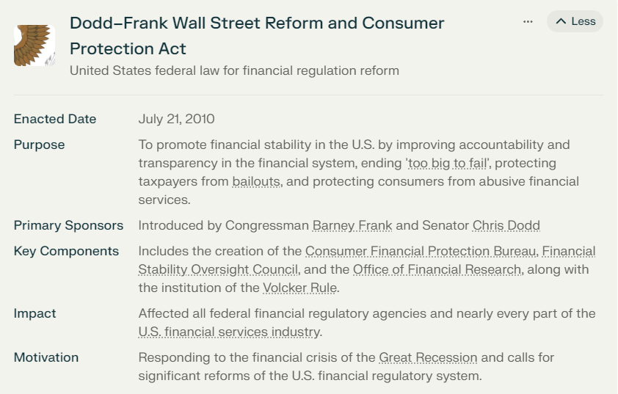

The Dodd-Frank Wall Street Reform and Consumer Protection Act is a comprehensive United States federal law enacted in 2010 to improve accountability and transparency in the financial system, end "too big to fail," and protect consumers from abusive financial practices. Here are key aspects of the law and its impact on the US banking system:

Key Provisions

1. **Financial Stability Oversight Council (FSOC)**: Created to identify and address systemic risks to the financial system, ensuring that large financial institutions do not pose a threat to the economy.
2. **Consumer Financial Protection Bureau (CFPB)**: Established to protect consumers from unfair and deceptive financial practices, particularly in areas such as mortgages, credit cards, and student loans.
3. **Volcker Rule**: Prohibits commercial banks from engaging in proprietary trading and investing in private equity funds and hedge funds, aiming to reduce systemic risk.
4. **Whistleblower Program**: Encourages reporting of financial violations by offering rewards to whistleblowers, enhancing transparency and accountability.
5. **Regulatory Reforms**: Consolidated regulatory agencies, increased oversight of systemic risk, and enhanced transparency in financial markets, including derivatives and credit rating agencies.

Impact on the US Banking System

1. **Increased Regulation**: The law aimed to prevent future financial crises by subjecting banks to stricter regulations, ensuring they are better capitalized and more resilient.
2. **Consumer Protection**: The CFPB and other agencies work to protect consumers from predatory lending practices and ensure transparency in financial products and services.
3. **Financial Stability**: The FSOC and other regulatory bodies monitor and address systemic risks, reducing the likelihood of another financial crisis.
4. **Compliance Burdens**: Critics argue that the law's compliance requirements can be burdensome for banks, potentially hindering their ability to compete globally.
5. **Economic Impact**: Studies suggest that the law has improved financial stability and consumer protection, although there is ongoing debate about its economic effects.

Timeline and History

1. **Introduction**: President Barack Obama proposed the legislation in June 2009, following the 2008 financial crisis.
2. **Enactment**: The law was enacted on July 21, 2010, named after Senators Christopher Dodd and Barney Frank, who introduced the bill.
3. **Reforms and Reviews**: The law has undergone partial repeal and review, with the Economic Growth, Regulatory Relief, and Consumer Protection Act of 2018 making some changes to the original legislation.

Overall, the Dodd-Frank Act represents a significant overhaul of the US financial regulatory system, aiming to promote financial stability, protect consumers, and prevent future crises.

**The Sarbanes-Oxley Act (SOX)**

The Sarbanes-Oxley Act (SOX) is a United States federal law enacted in 2002 to protect investors and the public from corporate fraud and financial errors. It was passed in response to high-profile scandals involving companies like Enron, Tyco, and WorldCom, which had compromised sensitive data and led to financial losses. Here are key aspects of SOX and its impact on the US banking system:

Key Provisions and Impact

1. **Corporate Governance**: SOX strengthened audit committees by granting them increased authority to oversee accounting decisions and ensuring that they are composed of independent members. This enhanced governance helps prevent fraudulent activities.
2. **Personal Responsibility**: The act requires top management to personally certify the accuracy of financial reports. False certifications can lead to imprisonment and fines, making executives more accountable for financial reporting.
3. **Disclosure Requirements**: Public companies must disclose material off-balance sheet arrangements, pro forma statements, and other financial information to ensure transparency. This helps investors make informed decisions.
4. **Harsher Penalties**: SOX introduced harsher penalties for securities fraud, mail fraud, wire fraud, and obstruction of justice. This includes increased prison sentences and fines for public companies committing these offenses.
5. **Internal Controls**: Section 404 of SOX requires public companies to perform extensive internal control tests and include an internal control report with their annual audits. This ensures that financial data is accurately reported and controlled.

Compliance and Benefits

1. **SOX Compliance**: Compliance involves ensuring that financial reports are accurate, internal controls are in place, and data security policies are formalized and enforced. This helps prevent financial errors and fraud.
2. **Benefits**: SOX compliance has several benefits, including improved corporate governance, increased accountability, enhanced auditor independence, and fewer financial restatements. These improvements contribute to a more transparent and trustworthy financial system.

Impact on US Banking System

1. **Financial Reporting**: SOX ensures that financial reports are accurate and transparent, which is crucial for the stability of the US banking system. Accurate financial reporting helps investors make informed decisions and reduces the risk of financial instability.
2. **Risk Management**: The act's emphasis on internal controls and risk management helps banks and other financial institutions identify and mitigate potential risks, reducing the likelihood of financial losses.
3. **Data Security**: SOX's data security requirements help protect sensitive financial data and prevent unauthorized access, which is critical for maintaining the integrity of the banking system.
4. **Auditing and Oversight**: The Public Company Accounting Oversight Board (PCAOB) established by SOX provides independent oversight of auditing firms, ensuring that audits are conducted with integrity and transparency. This helps maintain trust in the financial system.

| **Provision** | **Description** | **Impact** |
| --- | --- | --- |
| **Strengthened Audit Committees** | Increased authority for audit committees to oversee accounting decisions | Improved corporate governance and accountability |
| **Personal Responsibility for Financial Reporting** | CEOs and CFOs must certify financial reports | Enhanced accountability and deterrence of fraud |
| **Enhanced Disclosure Requirements** | Disclosure of off-balance sheet arrangements, pro forma statements, and insider transactions | Increased transparency and investor confidence |
| **Harsher Penalties for Fraud and Obstruction** | Increased prison sentences and fines for securities fraud, mail fraud, wire fraud, and obstruction of justice | Deterrent effect on fraudulent activities |
| **Costly Internal Controls** | Section 404 requires extensive internal control tests and reporting | Compliance costs and potential distraction from core business activities |
| **Public Company Accounting Oversight Board (PCAOB)** | Sets standards for public accountants, limits conflicts of interest, and mandates lead audit partner rotation | Improved audit quality and investor confidence |
| **Section 302 Certification** | Mandates CEO and CFO certifications of financial reports | Enhanced accountability and deterrence of fraud |
| **Section 404 Internal Controls** | Requires public companies to report on internal controls over financial reporting | Improved financial reporting and investor confidence |
| **Section 802 Recordkeeping** | Specifies rules for record retention and destruction | Compliance with electronic recordkeeping requirements |
| **Auditor Independence** | Prohibits certain non-audit services and requires communication between auditors and audit committees | Improved auditor independence and investor confidence |

In summary, the Sarbanes-Oxley Act plays a crucial role in maintaining the integrity and transparency of the US banking system by ensuring accurate financial reporting, robust internal controls, and enhanced data security.